Task 14
1. Check WSL status
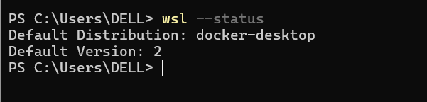
Step 1 — Check installed WSL distributions
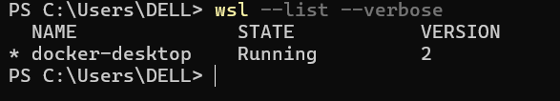
Step 1 — Record your current environment
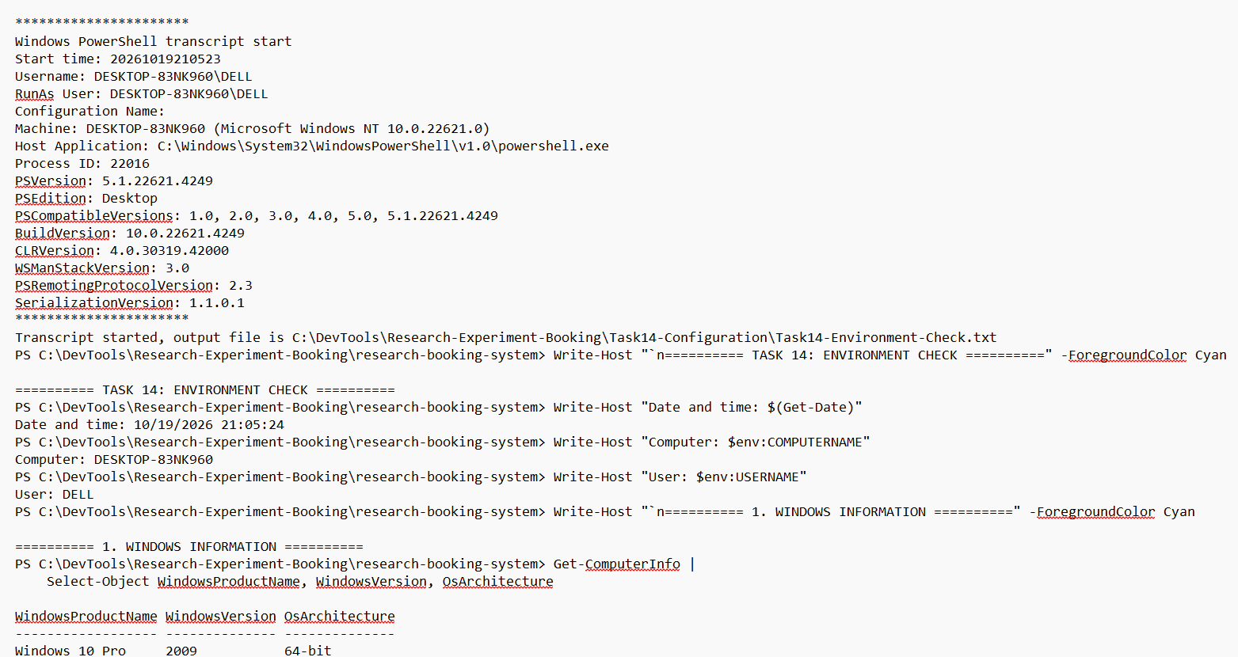
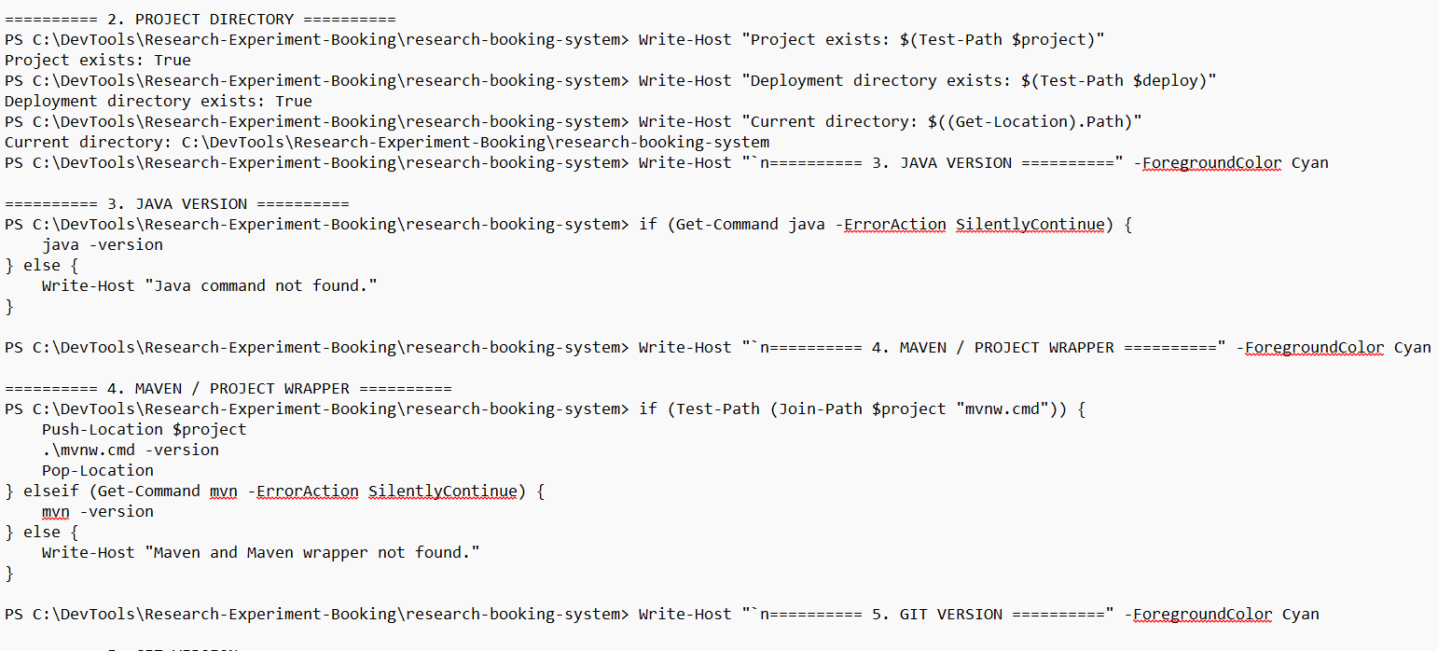
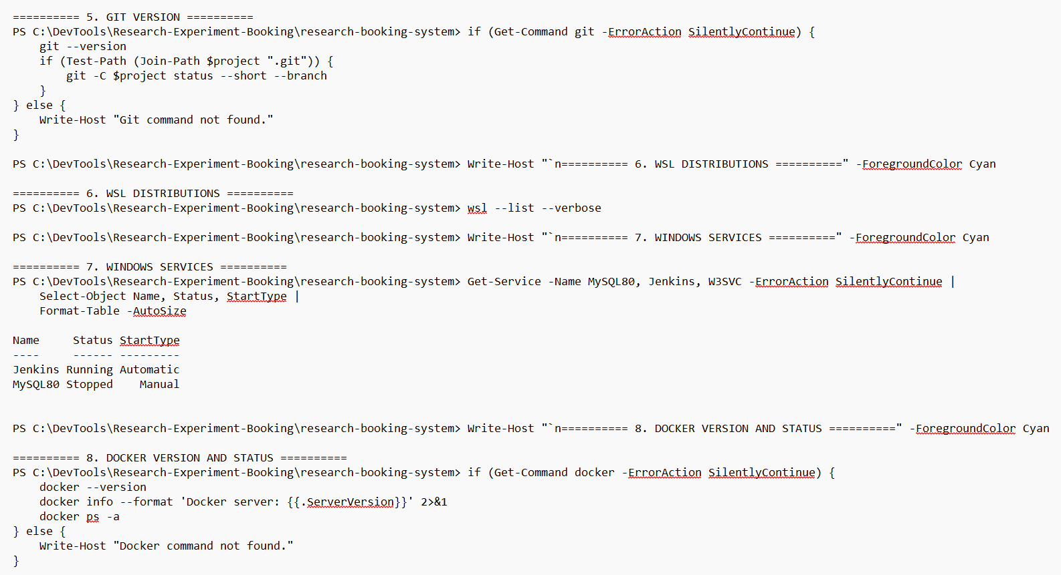

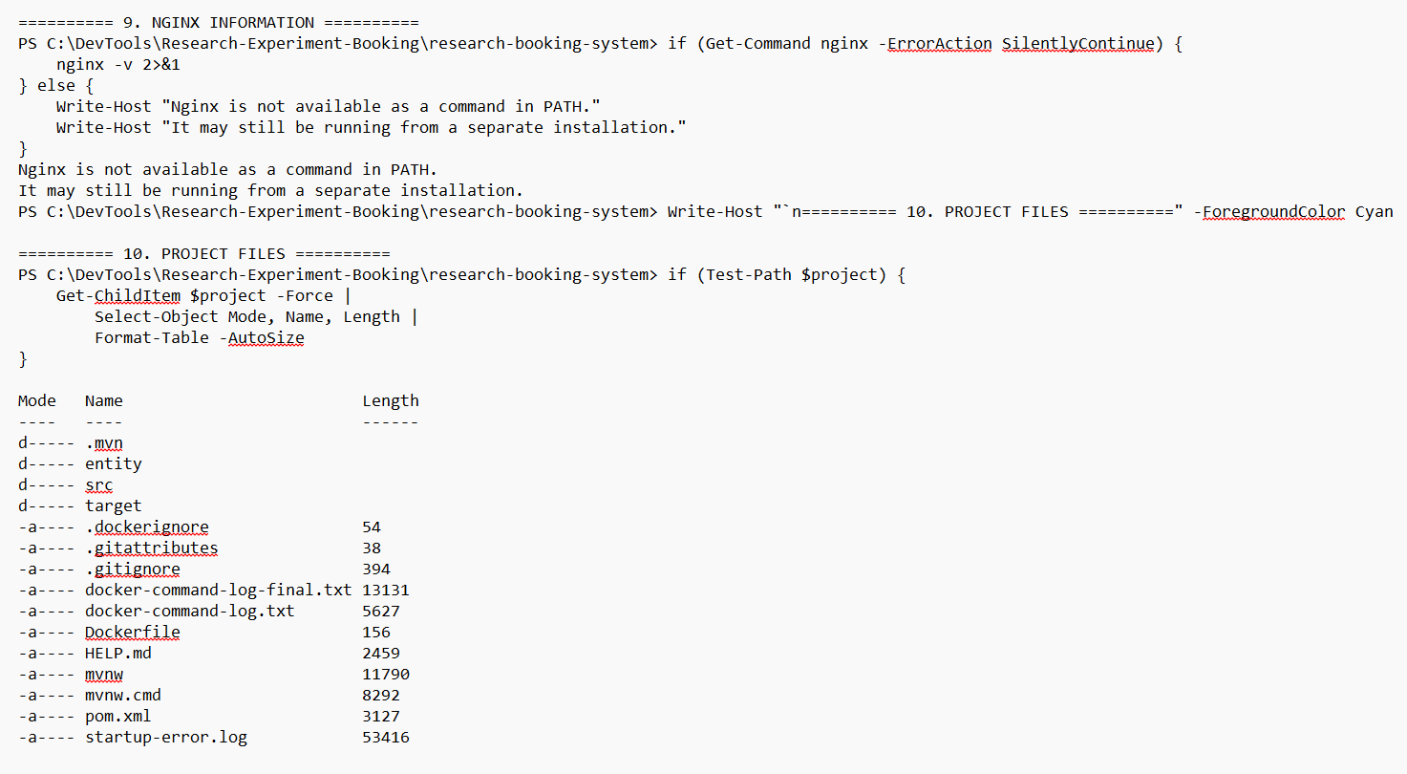
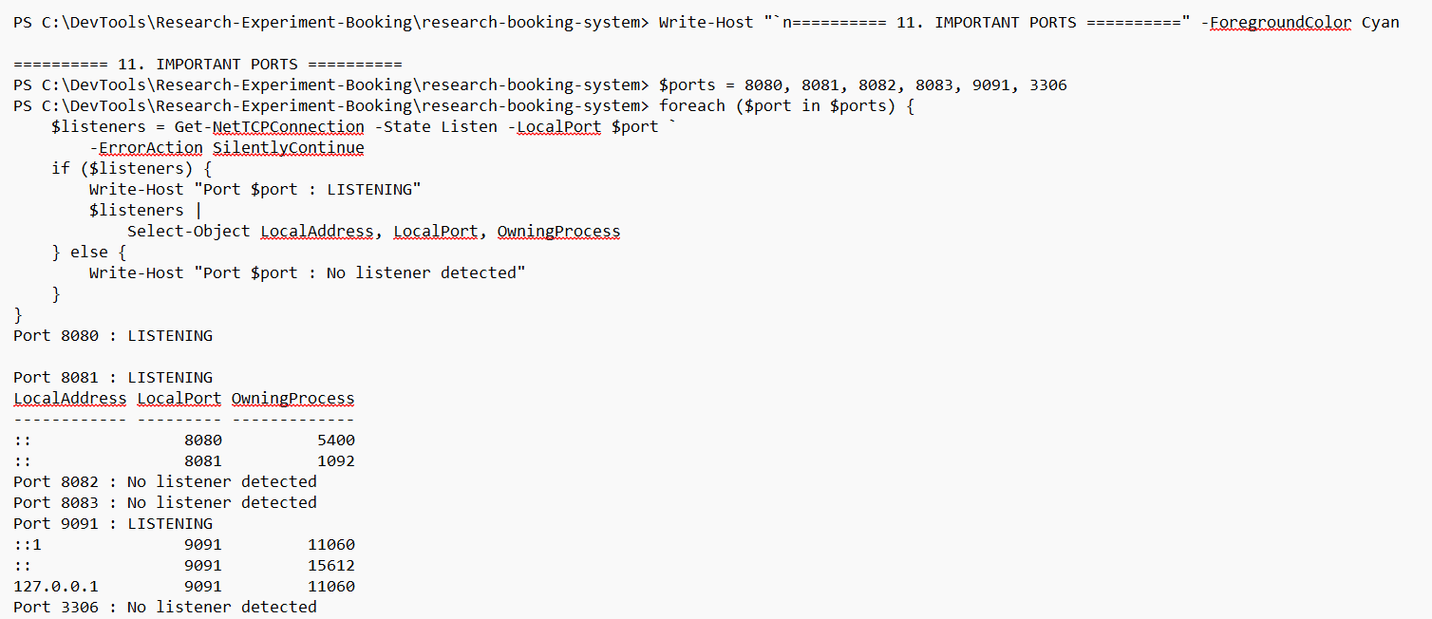
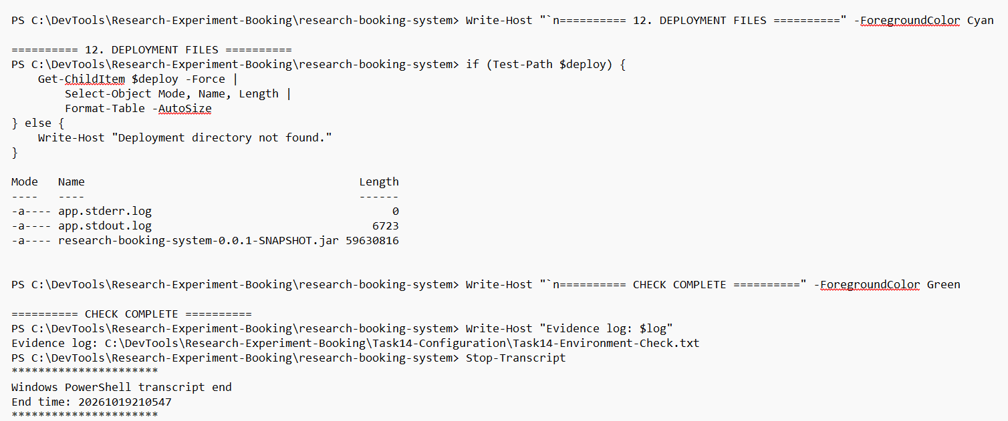
Step 2 — Install Ubuntu for Ansible
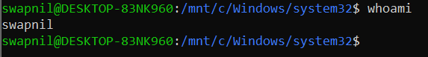
sudo apt update
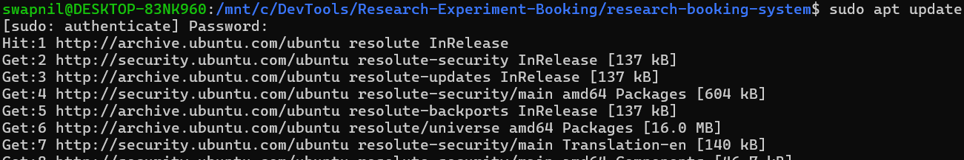
Install Ansible
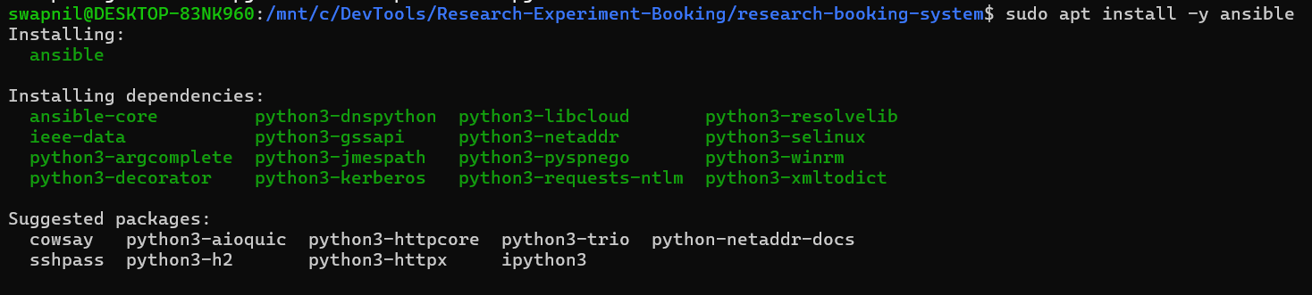
Verify Ansible
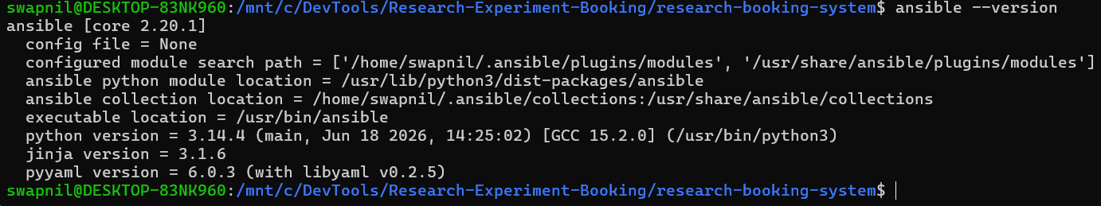
Create the Task 14 folder
Create the Ansible inventory
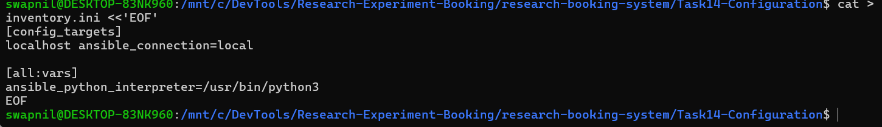
Verify the inventory
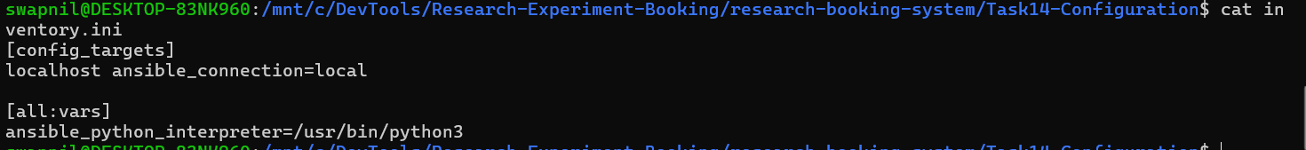
Test the Ansible connection
Create playbook.yml
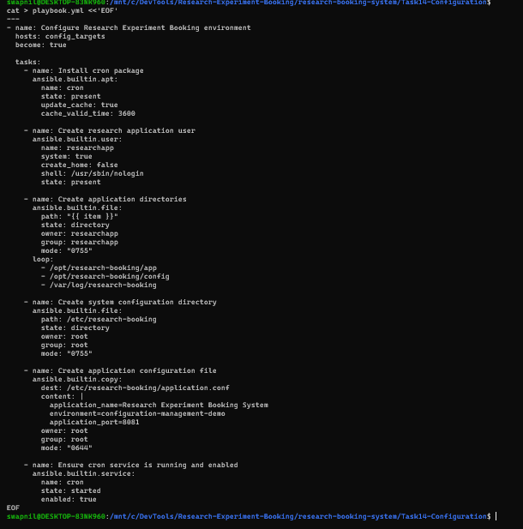
Check the playbook syntax
Execute the playbook
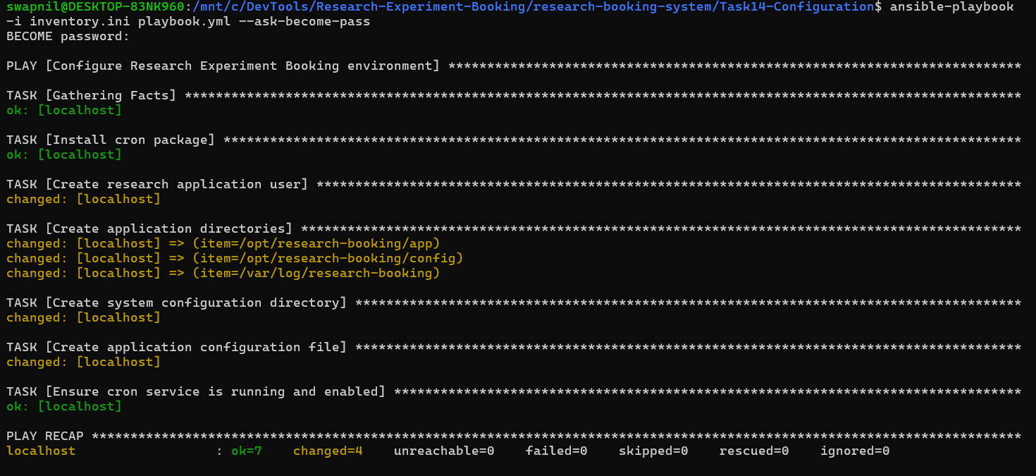
Save the first execution log
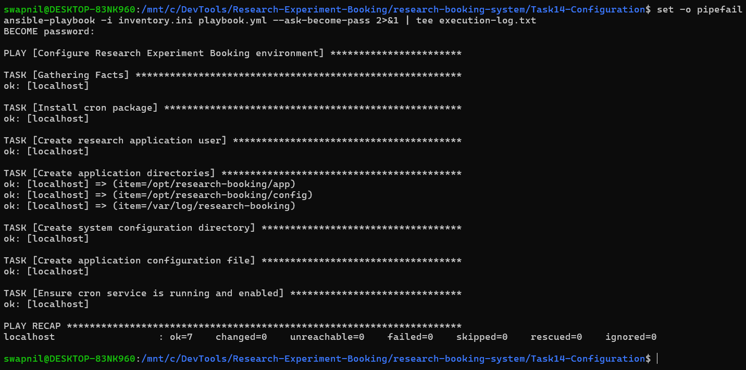
Verify the files and configuration
Display the configuration file
Check the cron service
Verify the application user
Verify the directories
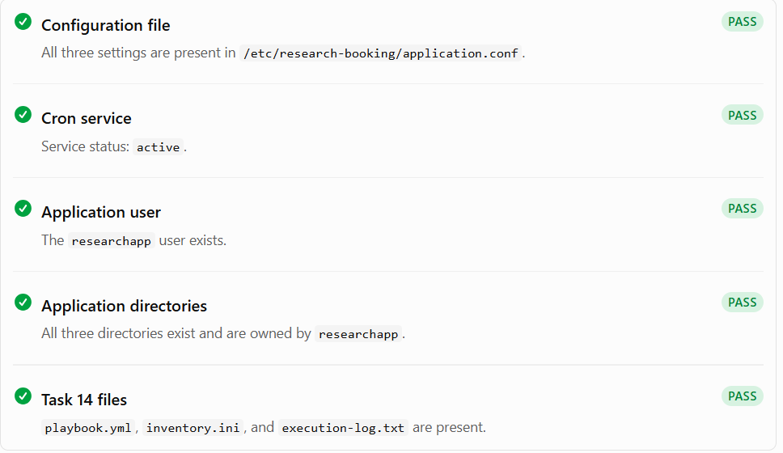
Ansible Configuration Management — Task 14
This task demonstrates configuration management using Ansible on Ubuntu running through Windows Subsystem for Linux (WSL). Ansible automates the installation of required packages, creation of application users and directories, generation of configuration files, and management of system services for the Research Experiment Booking System.
Objectives
- Automate environment configuration using an Ansible playbook.
- Install and verify the cron package.
- Create the researchapp application user.
- Create application, configuration, and log directories.
- Generate the application configuration file.
- Ensure the cron service is running and enabled.
- Record execution results for project submission.
Tools and Environment
Component | Technology
Operating system | Ubuntu on WSL
Configuration management | Ansible
Target host | Localhost
Privilege escalation | sudo
Service management | systemd
Application | Research Experiment Booking System
Task 14 Directory Structure
The Ansible configuration files are stored in the following directory:
research-booking-system/
└── Task14-Configuration/
├── inventory.ini
├── playbook.yml
└── execution-log.txt
- inventory.ini — Defines the target host used by Ansible.
- playbook.yml — Contains the automation tasks for configuring the environment.
- execution-log.txt — Records the output of the successful playbook execution.
Ubuntu / WSL Setup and Execution
Open Ubuntu (WSL) and navigate to the Task 14 directory:
cd /mnt/c/DevTools/Research-Experiment-Booking/research-booking-system/Task14-Configuration
Verify the Ansible installation:
ansible --version
Check that the local target is reachable:
ansible -i inventory.ini localhost -m ping
Expected result:
localhost | SUCCESS => {
"changed": false,
"ping": "pong"
}
Execute the Ansible playbook with sudo authentication:
ansible-playbook -i inventory.ini playbook.yml --ask-become-pass
Enter your Ubuntu/WSL password when prompted for the become password.
To save the execution output in a log file, run:
set -o pipefail
ansible-playbook -i inventory.ini playbook.yml --ask-become-pass 2>&1 | tee execution-log.txt
The pipefail option ensures that a failed playbook command is not hidden by the successful execution of tee.
Configuration Verification
Verify that the application configuration file was created:
cat /etc/research-booking/application.conf
Expected configuration:
application_name=Research Experiment Booking System
environment=configuration-management-demo
application_port=8081
Check that the cron service is active:
systemctl is-active cron
Expected output:
active
Verify the application user:
id researchapp
Verify the application, configuration, and log directories:
ls -ld /opt/research-booking/app /opt/research-booking/config /var/log/research-booking
Confirm that the submission files exist:
ls -l
Execution Results
The Ansible playbook completed successfully with the following results:
PLAY RECAP
localhost : ok=7 changed=0 unreachable=0 failed=0 skipped=0 rescued=0 ignored=0
The execution verified that all seven tasks completed without errors. The changed=0 result indicates that the system was already in the desired state when the playbook ran.
The following configuration checks were also successful:
- Application configuration file created and verified.
- Cron service confirmed as active.
- Application user and required directories available.
- Execution log saved as execution-log.txt.
Task 14 Submission Checklist
Before submitting the configuration-management task, ensure the following files are available in Task14-Configuration:
- playbook.yml — Ansible automation playbook.
- inventory.ini — Target host configuration.
- execution-log.txt — Successful execution log.
Keep screenshots of the successful Ansible playbook recap, the application configuration file, and the cron service status as supporting evidence for the college submission.
Note: This task configures the local Ubuntu/WSL environment. It does not automatically deploy or restart the Spring Boot application on port 8081; application deployment remains a separate step in the project's deployment workflow.

